Local Web QR generator

This web application is meant to be hosted locally in the first line of the chain (factories, production places etc).

Libraries used:

* Javascypt - <https://www.fourmilab.ch/javascrypt/pass_phrase.html>
* QR generator - <https://davidshimjs.github.io/qrcodejs/>

Files to take note of:

* pass_phrase.html – The view page
* js/controller.js – Contains all the logic for the web app, and also the functions done in the background.

Installation steps:

1. Have Xampp installed on a computer
2. Download files from <https://github.com/xLesterGG/generateQR>
3. Rename the folder to generate and move them to YourDriveLetter:\xampp\htdocs, the final path should look something like C:\xampp\htdocs\generate.  
     
   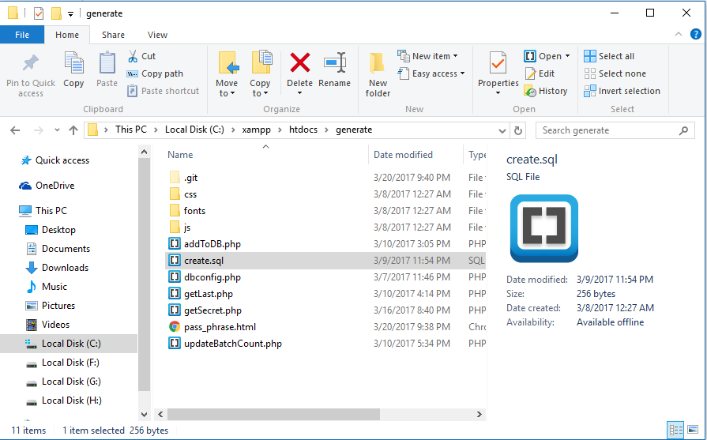
4. Launch Apache and MySQL from Xampp control panel.

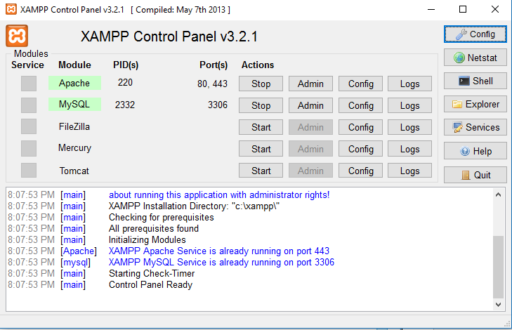

1. Navigate to localhost/phpmyadmin and click on the SQL tab

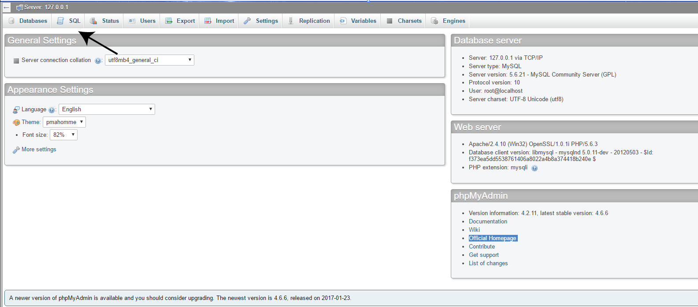

1. 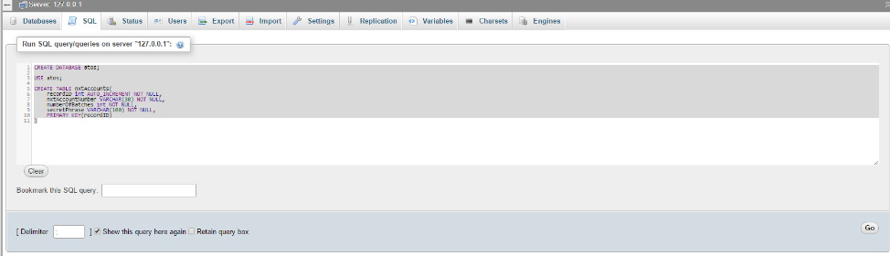Copy the content from C:\xampp\htdocs\generate\create.sql and paste it inside the text field. Then press go to create the database.
2. Navigate to <http://localhost/generate/pass_phrase.html>. The web application should be loaded and everything should work well.
3. Should the mySQL database have a non-default username and password, change them in dbconfig.php.